# Overview

Upon completion of this chapter, the participant will be able to:

* Explain what causes an overallocated resource.
* List techniques to solve resource overallocations.
* List techniques to shorten the schedule.
* Work with Task Inspector and Team Planner view.
* Define a baseline.
* Set a baseline in PWA or Project Pro.
* Discuss scope changes and options to update a baseline.

# Finalizing a Schedule

An often overlooked piece of scheduling is tracking. For tracking to be effective, it should be accompanied by a process for finalization and approval of your schedule before work is begun. The main goal here is to ensure your project is finalized and ready to receive updates. The first steps toward finalizing your schedule are resolving resource overallocations and ensuring your schedule is optimized to meet project deadlines.

## Resolving Resource Overallocations

If you discover that – due to the limits of your resources – you will be unable to complete the project on schedule, you already have an unrealistic project plan. At Advisicon, we recommend that you solve these problems before finalizing your schedule.

The most common resource conflict is resource overallocation. This kind of resource conflict means that the conflicted resources have more work assigned to them than they can realistically complete in the given time frame.

While there are multiple ways to alter resource allocation, it is important to find and analyze its source. As part of your analysis, evaluate the overall effect of fixing the overallocation on the project schedule before making changes.

Some options to consider for solving resource overallocations are:

* Hire additional resources (see Resource Management in Project Pro)
* Replace a resource on a task (see Resource Management in Project Pro and Team Planner view)
* Assign a resource to work overtime (see Resource Management in Project Pro)
* Increase work time (calendar) (refer to the course Managing Projects in Project Pro 2013)
* Break a task up into smaller tasks
* Adjust the division of work across the task (work contour) (see Resource Mangement in Project Pro)
* Move the task until the resource is available
* Delete tasks (see Scheduling)
* Change overlapping tasks into sequential tasks by using Project’s leveling feature

For Project’s automatic leveling to be effective in Project Server, it requires that the project manager or scheduler have the ability to open and edit all other projects that the resource is working on. In most organizations, this is not the case. So, at Advisicon, we recommend our clients manually solve resource overallocations using other methods instead; therefore, leveling is not covered in this book.

* Use Task Inspector to solve the problem
* Use Team Planner to solve the problem

### Hire Additional Resources

Hiring is a project management technique which may mean negotiation for new resources. Refer to Resource Management in Project Pro to review techniques for adding resources to your team and changing assignments.

### Replace a Resource on a Task

Refer to Resource Management in Project Pro to learn more about resource assignments and replacing resources. Also refer to Team Planner view.

### Assign a Resource to Work Overtime

Refer to Resource Management in Project Pro to review the technique to display Resource Usage view and where work hours can be increased on a daily basis. Note: using the overtime work column only offers an advantage if you are paying your resource a different overtime rate.

### Increase Working Time

In a Project Server environment, the calendar may be controlled by the administrator. If you have the option to change it, refer to the course Managing Projects in Project Pro 2013.

### Break a Task Up Into Smaller Tasks

This is a project management technique where you take a long task and divide it up into a collection of smaller tasks. Then you can distribute the pieces to different resources as desired.

### Adjust the Division of Work Across the Task

Refer to Resource Mangement in Project Pro and how to use Resource Usage view to display and edit work values on a daily basis. Adjusting the work in this manner is called work contouring because it may resemble a pattern or shape if graphed (e.g. turtle).

### Delete Tasks

This is a project management technique where you are cutting scope by deleting tasks. To learn more about deleting tasks refer to Scheduling.

### Move a Task Until the Resource is Available

1. In the Task tab, in the View group, click Gantt Chart.
2. Select the task with the overallocated resource. The red overallocation indicator appears in the Indicators column as a reminder.
3. In the Tasks tab, in the Tasks group, click the Move dropdown and then click the desired choice.

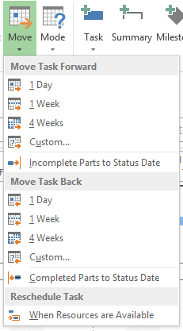

1. Moving a Task Feature [Moving a Task Feature Large.tif]

The Move option When Resources are Available works kind of like leveling. The difference is that it is specific to one task instead of the entire project. Moving one task is often preferred since it eliminates surprises to the project manager who often sees an entire project shift when leveling is applied.

Moving a task using any of the options in the Move dropdown creates a constraint on that task. Since you are moving the task due to a resource limitation, you are modeling a situation where the links between tasks do not allow you to work on the task as scheduled and therefore a constrained task is needed.

### How to Use Task Inspector

1. In the Task tab, in the View group, click Gantt Chart.
2. In the Tasks tab, in the Tasks group, click Inspect. Notice the pane that appears to the left of the Gantt Chart.

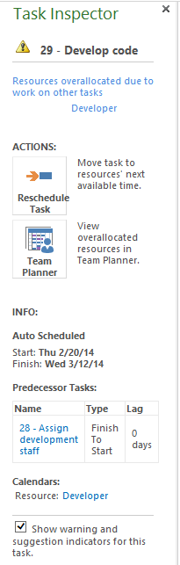

1. Using Task Inspector to Evaluate Task [Using Task Inspector to Evaluate Task.tif]
2. Click any desired task. View the information and recommendations in the Task Inspector.

* You can click other tasks to view their information.
* You can follow a recommended action in the Task Inspector pane.

1. Click Close (X) on the Task Inspector pane to hide it.

Task inspector only shows the details of one task at a time.

### How to Use Team Planner

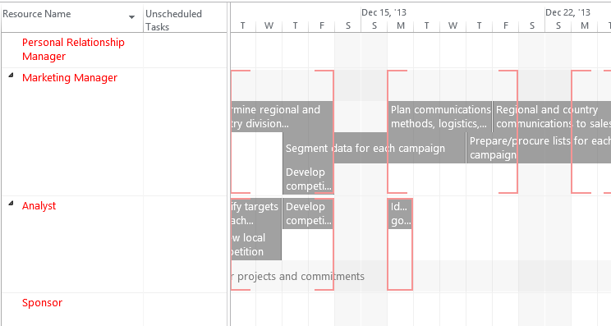

1. Team Planner View with Overallocated Resources [Planner View with Overallocated Resources.tif]
2. In the Task tab, in the View group, click the Gantt Chart dropdown and click Team Planner.
3. Locate the overallocated resource and task you wish to make changes to.

* Hover on the task to view relevant details.
* Right-click on the task name to quickly reassign the task, delete it, or inactivate it.
* Double-click the task to view the Task Information dialog box and make any needed changes.
* Drag the task in team planner view to reassign or move the task to a locked in time period (sets a constraint)

1. In the File tab, click Publish to save the changes and share them with your project team via PWA.

Warning – If you see blank information within brackets on the right side of the view (the timescale), you will need to zoom out so the text crossing over multiple time periods can be displayed.

Double-click Other projects and commitments if you want to see the names of other projects your resources have been assigned to that are not currently open.

## Optimizing the Schedule to Meet Deadlines

Scheduling involves more than creating a detailed schedule and assigning resources; it also involves modifying the schedule to meet goals and to work within limitations. Typically, there are deadlines within your schedule that must be met to satisfy the requirements of your sponsor. If your schedule shows that you are missing those deadlines, you need to take steps to optimize the schedule.

In most cases, optimizing the schedule requires you to shorten your project’s overall finish date. The finish date is driven by the critical path of your project. The critical path includes those tasks that drive the total duration of your project. If a critical task finishes late, it delays the entire project. If a critical task finishes early, it shortens the duration of the project. If you shorten the length of the critical path, you shorten the duration of your project, and your project finishes sooner.

Listed below are some options to shorten your schedule. The method you choose depends on your individual project and the resources you have available.

* Assign additional resources (see Resource Management in Project Pro)
* Assign a resource to work overtime (see Resource Management in Project Pro)
* Increase working time (calendar) (refer to the course Managing Projects in Project Pro 2013)
* Break task into smaller tasks
* Overlap key activities (multi-tasking)
* Change dependencies of tasks
* Delete tasks (see Scheduling)
* Redefine quality (less time on activities) (see Schedule)
* Break project into phases (see Schedule)
* Use Task Inspector to solve the problem (see How to Use Task Inspector)
* Use Team Planner to solve the problem (see How to Use Team Planner)

Optimizing the schedule and shortening the critical path may create new resource overallocations. You should watch for the Overallocation Indicator icon in the Indicators column to alert you that you need to address a new resource overallocation.

Besides giving useful tips to solve overallocated resources, Team Planner shows you predecessor tasks, constraints, and task calendars which could be useful to help you determine what is causing a task to start at a particular time. Accessing Team Planner and Task Inspector are covered in How to Use Task Inspector.

### Assign Additional Resources

Refer to Resource Management in Project Pro to review techniques for assigning resources and how duration is shortened on Fixed Work tasks. You can also do this with Team Planner view.

### Assign a Resource to Work Overtime

Refer to Resource Management in Project Pro to review the technique to display Resource Usage view and where work hours can be increased on a daily basis. Note: using the overtime work column only offers an advantage if you are paying your resource a different overtime rate.

### Increase Working Time –

In a Project Server environment, the calendar may be controlled by the administrator. If you have the option to change it, refer to the course Managing Projects in Project Pro 2013.

### Break the Task into Smaller Tasks

This is a project management technique where you take a long task and divide it up into a collection of smaller tasks. Then you can apply the technique to overlap some of these tasks will shorten the overall duration.

### Delete Tasks

This is a project management technique where you are cutting scope by deleting tasks. To learn more about deleting tasks refer to Scheduling.

### Refine Quality

This is a project management technique where you reduce the time given to the task and accept a reduced quality of your output. For example, you could skip proofreading pass two on a book and accept that some errors will be in the final book.

### Break the Project Into Phases

This is a project management technique where you choose to group the project into phases and postpone some phases to a later time to complete the project sooner. Refer to Schedule for details about creating Summary tasks.

### Overlap Tasks or Change Dependencies

Overlapping critical tasks is one of the most popular methods to shorten the schedule. It is sometimes referred to as “fast-tracking your schedule.”

1. In the Format tab, in the Bar Styles group, click the Critical Tasks checkbox. This will change the Gantt bar color from blue to red for critical tasks. Since the critical tasks drive the end date of your project, it is useful to have them visible.
2. Locate two linked tasks you want to overlap.
3. Double-click the successor (dependent) task.
4. In the Task Information dialog box, click the Predecessors tab.
5. On the row of the desired predecessor task, in the Type dropdown list, make the desired change. In the Lag field click the dropdown list or type the desired change.

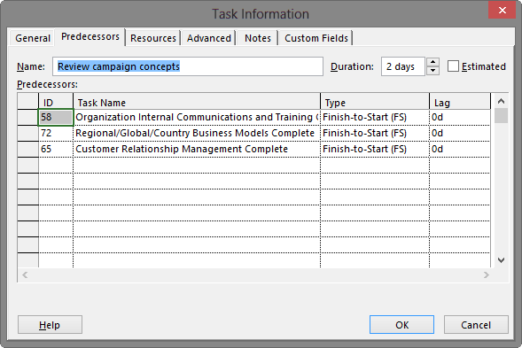

1. Predecessors Tab of Task Information Dialog Box [Predecessors Tab of Task Information Dialog Box.tif]
2. The most popular link scenarios for overlapping tasks are:

* Finish to Start with negative lag
* Start to Start
* Finish to Finish
* Start to Start with positive lag
* Finish to Finish with negative lag

Creating a full overlap of tasks or partial overlap of tasks is a personal choice. Advisicon recommends you evaluate the risk to your schedule when deciding how much overlap is appropriate.

If the same resource is needed for both tasks, you may discover that a full overlap of tasks will overallocate the resource while a partial overlap may not.

There are some tasks where the risk would be lower if you do a partial overlap and get some progress underway on the predecessor task before starting the successor task. An example of this could be where you are creating the start of a model of a building slightly before you start the detailed architectural drawings. The model can be manipulated along the way and you will not have to lose all the work on the architectural drawings because the efforts are staggered.

Changing links may change the tasks on the critical path, be sure to watch for that.

1. Click OK.

### Assign Additional Resources

1. In the Format tab, in the Bar Styles group, click the Critical Tasks checkbox. This will change the Gantt bar color from blue to red for critical tasks. Since the critical tasks drive the end date of your project, it is useful to have them visible.
2. Locate the task you want to shorten.
3. Double-click the task. In the Task Information dialog box, click the Advanced tab and ensure the task is set to Fixed Work.

Warning – Assigning additional resources will only shorten Task Duration on Fixed Work tasks. It will not have any impact on Fixed Duration tasks.

1. In the Task Information dialog box, click the Resources tab.

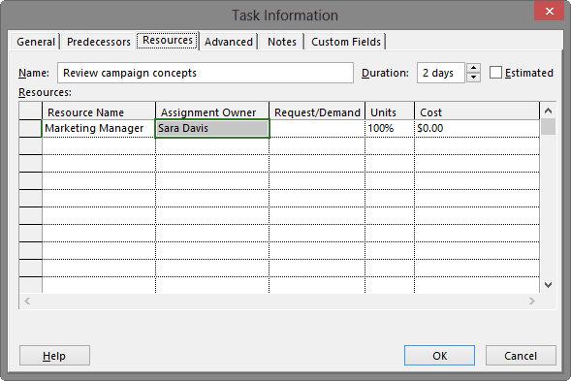

1. Resources tab in the Task Information Dialog Box [Resources tab in the Task Information Dialog Box.tif]
2. In the Resource Name column, in the first blank row, click the dropdown arrow and click the desired resource name and then click OK.
3. The task duration will automatically recalculate.

## Getting Final Schedule Approval

Your schedule is ready for final approval when it has been fully planned, resources have been assigned, and any overallocations or missed deadlines have been resolved. Since you have resolved all of the schedule issues, you now have a schedule which has a high probability of being fully executed by the team. Prior to getting started, you should have your final schedule approved.

Most schedules have a sponsor who is funding the project. The sponsor is typically the person who will be receiving the benefits of the project. Some organizations also have a committee or member of the project management office (PMO) who signs off on a schedule before the project gets started.

Receiving approval of the schedule from the sponsor before getting started will ensure there is initial agreement on the plan going forward.

At Advisicon, we recommend that you implement a formal schedule approval process before executing your project. This will allow time for a review of the schedule, time to make changes to the project, and time for a final approval all before any work has started and before funds have been spent on the execution of the project.

# Setting a Baseline

An important step when moving a schedule from planning to execution is capturing a baseline. In this section, we will provide a definition and purpose for the baseline, describe what happens when you capture a new or modified baseline, and illustrate how that information is used in scheduling.

## What is a Baseline?

A baseline is a snapshot of your schedule after it has been planned and approved. A baseline is a way to record planned information about dates, timeframes, costs, and planned work.

If you do not capture a baseline, planned information will always be equal to current information and your schedule will portray itself as always perfectly planned and on schedule.

A schedule that is not baselined may also appear to still be in development. Project managers typically capture a baseline to signal to the project team that work is ready to begin.

## Effects and Benefits of Setting a Baseline

Most project managers want to evaluate how the project plan is being executed by the team and how required schedule changes have altered the original plan. The quickest and simplest method to use Project Pro to illustrate variances between the original plan and the current plan is by setting a baseline before you start work.

Setting a baseline automatically keeps an original plan that can be displayed in a number of built-in views, such as Tracking Gantt view (shown below). As soon as the schedule shows progress, any variances will be displayed in those views.

Baseline information will remain frozen and will maintain values which can be compared against your schedule (most schedules fluctuate as work is performed and conditions in the project change). By setting a baseline, you are letting the software capture a copy of the data within specified columns at a point in time.

Five task columns are copied when you set a baseline: Start, Finish, Duration, Cost, and Work. The copied columns are maintained within the same schedule, in columns labeled with a “baseline” prefix such as Baseline Start. Project Pro uses these specific columns to calculate schedule variance during tracking.

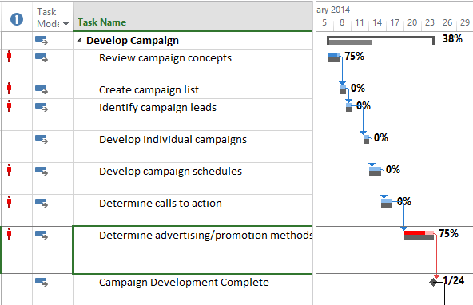

1. Tracking Gantt View with Baseline and Actual Task Status [Tracking Gantt View with Baseline and Actual Task Status.tif]

Besides offering the advantage of comparison, setting a baseline is also the way Project is able to conduct earned value analysis. By default, information stored in the Baseline and information captured through the Status date and % Complete fields calculate the earned value of a task. Earned value analysis is a respected project management method for evaluating schedule and cost performance. Earned value analysis can provide solid metrics that can drive business decisions on the uncompleted portions of the schedule.

For more information on earned value and costing, see Advisicon’s book Advanced Scheduling with Microsoft Project.

## Setting a Baseline for the Entire Project

Organizations that want to use Project for tracking will need to set a complete baseline for the entire project at least once during the project. A complete baseline means you are capturing baseline information for every task in the schedule. Baseline information along with the current schedule information is visible in several tracking views.

As a best practice, you should set a baseline before approving task updates from team members in PWA.

To set a baseline in Project Pro:

1. If needed, click Check Out on the status line to change the schedule to read-write mode for editing.
2. In the Project tab, in the Schedule group, click the Set Baseline dropdown and then click Set Baseline.

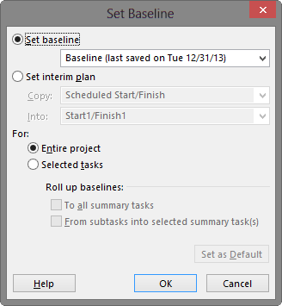

1. Set Baseline Dialog Box [Set Baseline Dialog Box.tif]
2. In the Set Baseline dialog box, click OK to accept the default settings.

To view the baseline in Project Pro:

1. In the Task tab, in the View group, click the Gantt Chart dropdown and click Tracking Gantt.

To set a baseline in PWA:

1. If needed, check out the schedule for editing. In the Project tab, Project group, click Edit.
2. In the Task tab, in the Editing group, click the Set Baseline dropdown, click the Set Baseline sub menu dropdown, and click the desired option. Watch the status message in the upper right corner to confirm the baseline was set.

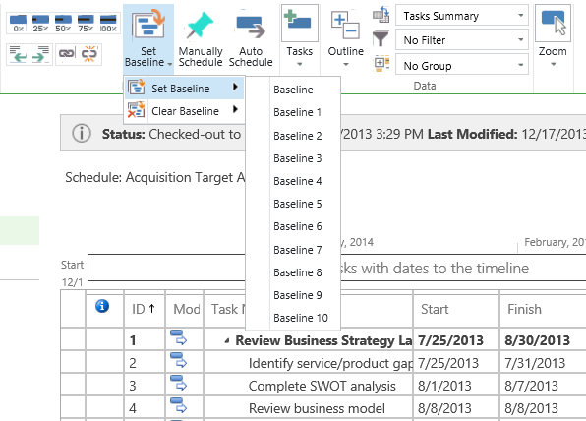

1. Set Baseline Option in PWA [Set Baseline Option in PWA.tif]

To view a baseline in PWA:

1. Task tab, in the Data group, click the Views dropdown, and click Tasks Tracking.

Project Server has a featured called Protected Baselines. Project managers by default are only given the ability to set the default Baseline (sometimes referred to as Baseline 0) and Baselines 6-10. Baselines 1-5 are reserved for Administrators.

## When to Set a New Baseline

As a baseline is used for capturing a schedule at a specific point in time, you can continue to use the same baseline as long as the information related to the original schedule remains the same. If the original schedule information is no longer relevant for comparison, you have the option to overwrite the original baseline or set a new baseline. Project Pro allows up to 11 different baselines per schedule. You can also set partial baselines for selected tasks. A partial baseline will use up one of the 11 available baselines but it will only contain information for selected tasks.

The default baseline is labeled Baseline, while all alternate baselines have a number in their name, such as Baseline 1, Baseline 2, etc. Any time you accept the default settings when setting a baseline, you are using Baseline.

Warning - Setting a baseline using default settings automatically overwrites the existing Baseline. This could overwrite historical information that you may desire later for comparison purposes.

One reason why the original baseline may no longer be valid is due to changes in scope. Scope changes may make a portion of the schedule (or the entire schedule) irrelevant.

Other reasons organizations use for setting a new baseline include setting historical reference points (such as yearly records), or completion of a project phase.

You should use an alternate baseline (baseline 1-10) to have a historical record of a version of your baseline. If you need more than 10 alternate baselines, you can use the option to Set Interim Plan, available within the Set Baseline dialog box, which provides 10 additional opportunities to capture historical information.

Alternate baselines are provided as a benefit to the project manager who would like to capture versions of baseline information when the scope of the schedule changes. For example, a project manager could use Baseline 1 to capture changes related to the first scope change and use Baseline 2 to capture changes related to the second scope change.

Best practice suggests only setting new baselines for scope changes when these changes have gone through an approval process such as a committee or executive sponsor.

Failure to follow an approval process may allow all changes to alter the complete baseline, making the baseline no longer a valid measure for planned versus actual progress.

Some project managers set a baseline when they have been assigned a new project that is currently in progress. This allows them to track only new variances since receiving the schedule.

To set a new baseline for selected tasks:

1. Select the tasks you want to update including all affected future tasks.
2. In the Project tab, in the Schedule group, click the Set Baseline dropdown and then click Set Baseline.
3. In the Set Baseline dialog box, in the For: section, click Selected Tasks.

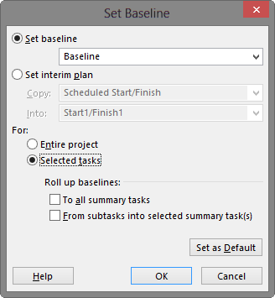

1. Set Baseline Dialog for Selected Tasks [Set Baseline Dialog for Selected Tasks.tif ]
2. If desired, in the Roll up baselines: section, you have two options:

* Click the To all summary tasks check box
* Click the From subtasks into selected summary task(s) checkbox

1. Click OK.

To set a new baseline for the entire project:

* Follow the steps from Setting a Baseline for the Entire Project

Pay attention to any dialog boxes that appear related to overwriting baseline information. The only way to recover an overwritten baseline is to immediately catch it with undo.

The Tracking Gantt view displays the default Baseline information against the actual. To replace with an alternate baseline, such as Baseline 1, you will need to customize the view.

PWA only allows you to set complete baselines for the entire project. If you need to set a baseline or update a baseline for selected tasks, you must use Project Pro.

# Key Points to Remember

* Overallocated resources occur when a resource is assigned more work than available in a given day.
* Moving a task in Gantt Chart view or Team Planner view is a popular method to solve a resource overallocation.
* Tasks on the critical path determine the end date of the project. Only by adjusting these tasks will the project end date be sooner.
* Overlapping tasks partially or fully is a popular method to shorten the project.
* Assigning additional resources will only shorten the duration of Fixed Work tasks.
* The schedule should be formally approved before setting a baseline.
* Setting a baseline saves a copy of specific columns of information at a specific point in time.
* The baseline can be updated partially or completely due to scope change.
* Setting a baseline in PWA should only be done when you want to capture a complete baseline for the entire project.